PHASE 1: AWS Account + Setup
Step 1: Create AWS Account
- Go to: https://aws.amazon.com/
- Click Create an AWS Account
- Add:
  - Email
  - Password
  - Card details (Free Tier — no charges if used correctly)
Step 2: Login to AWS Console
https://console.aws.amazon.com/
PHASE 2: Install AWS CLI (on Laptop)
Step 3: Download AWS CLI
- Go to: https://aws.amazon.com/cli/
- Download Windows installer (.msi)
- Install normally (Next → Next → Finish)
Step 4: Verify Installation
Open Command Prompt (CMD):
aws --version
Output should look like:
aws-cli/2.x.x Python/3.x
Step 5: Configure AWS CLI
In CMD:
aws configure
Enter:
AWS Access Key ID: (from IAM)
AWS Secret Access Key: (from IAM)
Default region: ap-south-1
Default output format: json
Step 6: Get Access Keys
- Go to AWS Console
- Search: IAM
- Go to:
  - Users → Create User
  - Enable Programmatic access
- Attach policy:
  - AdministratorAccess (for project simplicity)
- Create → Copy:
  - Access Key
  - Secret Key
PHASE 3: Create Lambda Function
Step 7: Open Lambda
- In AWS Console search: Lambda
- Click → Create Function
Step 8: Configure Function
- Select: Author from scratch
- Function name: pdcLambda
- Runtime: Python 3.10
- Click Create Function
Step 9: Write Code
Replace code with:
def lambda_handler(event, context):
name = "Guest"
if 'queryStringParameters' in event and event['queryStringParameters']:
name = event['queryStringParameters'].get('name', 'Guest')
return {
'statusCode': 200,
'body': f"Hello {name}, Serverless working!"
}
Click Deploy
Step 10: Test Lambda
- Click Test
- Create event:
{
"queryStringParameters": {
"name": "Sania"
}
}
Click Test → You should see:
Hello Sania, Serverless working!
PHASE 4: Create API Gateway
Step 11: Open API Gateway
Search: API Gateway
Click:
Create API
Step 12: Choose API Type
Select:
HTTP API (Recommended)
Click Build
Step 13: Connect Lambda
- Click Add Integration
- Select:
  - Lambda
  - Choose your function: pdcLambda
Step 14: Add Route
Set:
Method: GET
Path: /hello
Step 15: Deploy API
Click:
Deploy
You will get URL like:
https://abc123.execute-api.ap-south-1.amazonaws.com
PHASE 5: Test on Laptop (FINAL STEP)
Step 16: Test in Browser
Open browser and paste:
https://your-api-url/hello?name=Sania
Output:
Hello Sania, Serverless working!
PHASE 6: Test Using CMD (Optional but Good)
curl "https://your-api-url/hello?name=Sania"

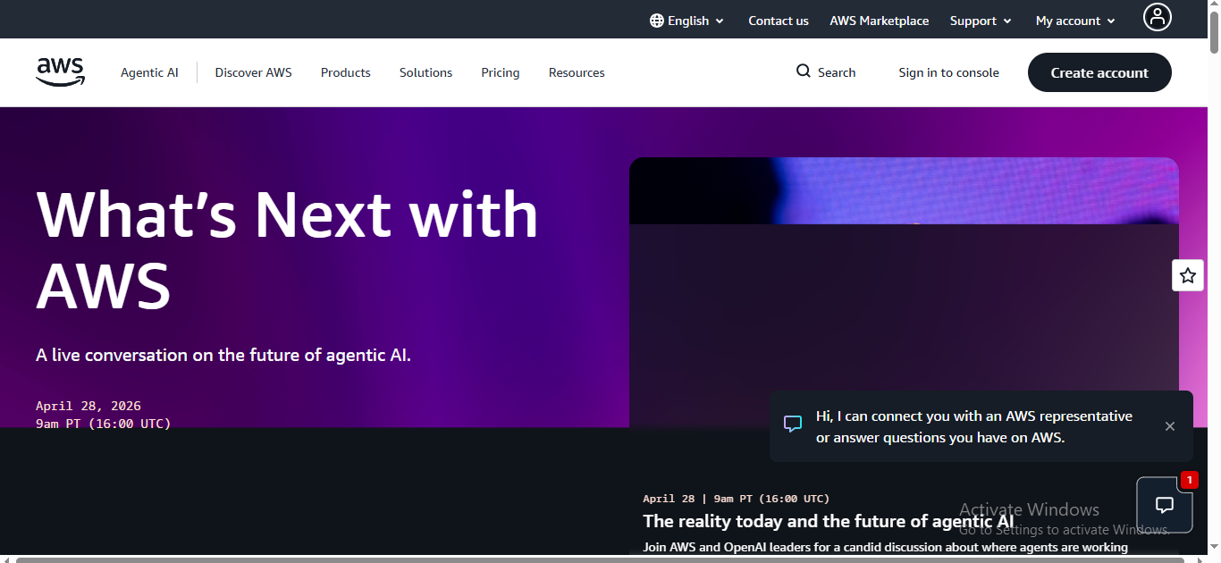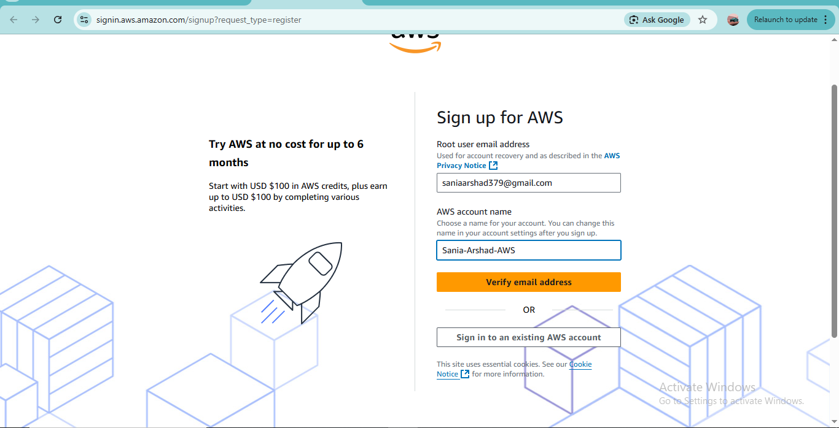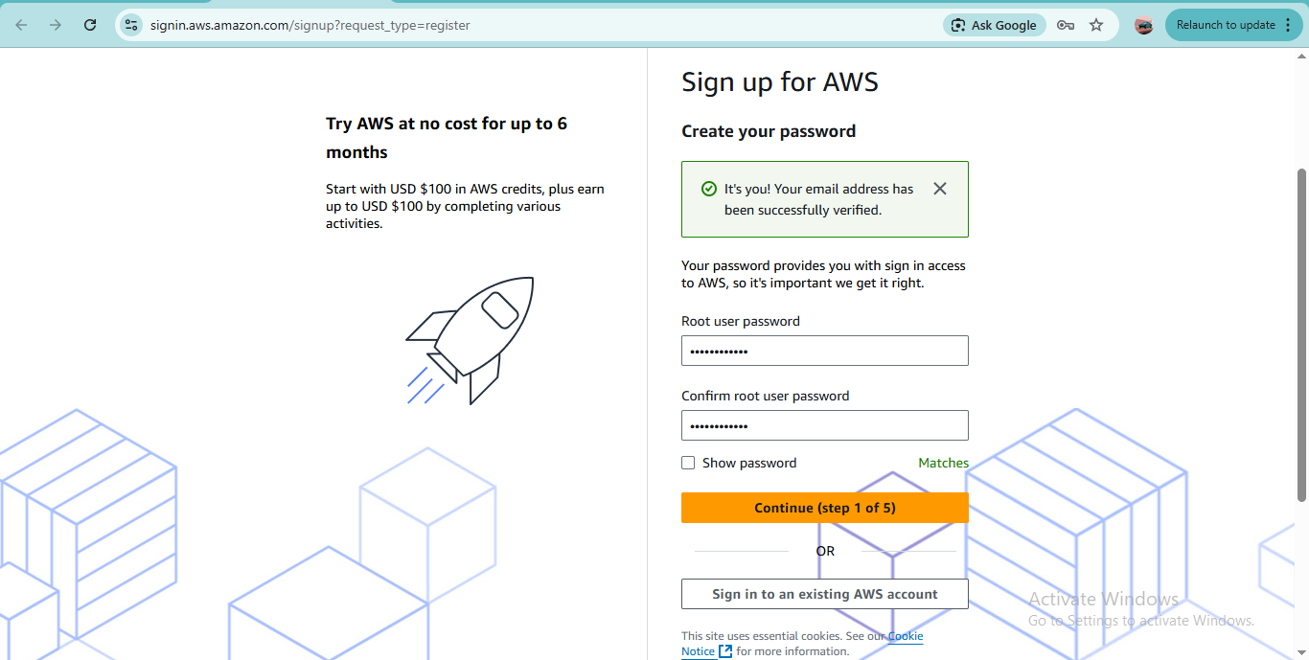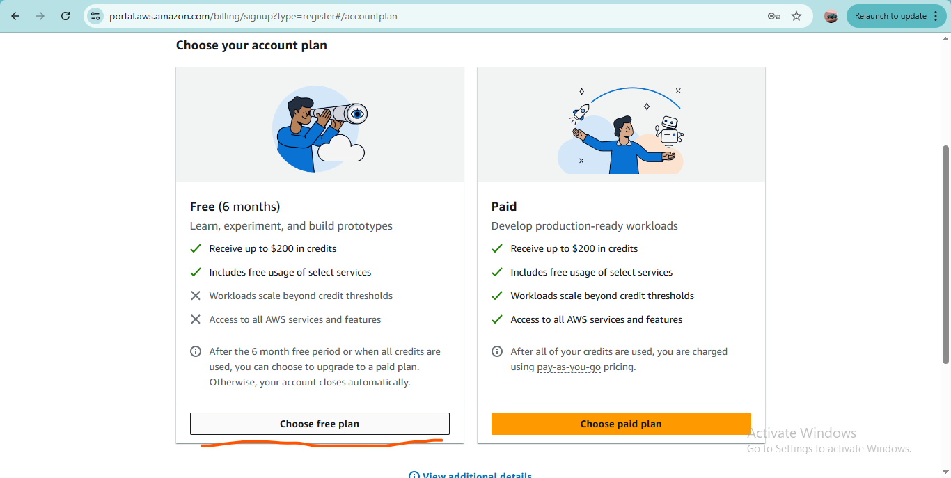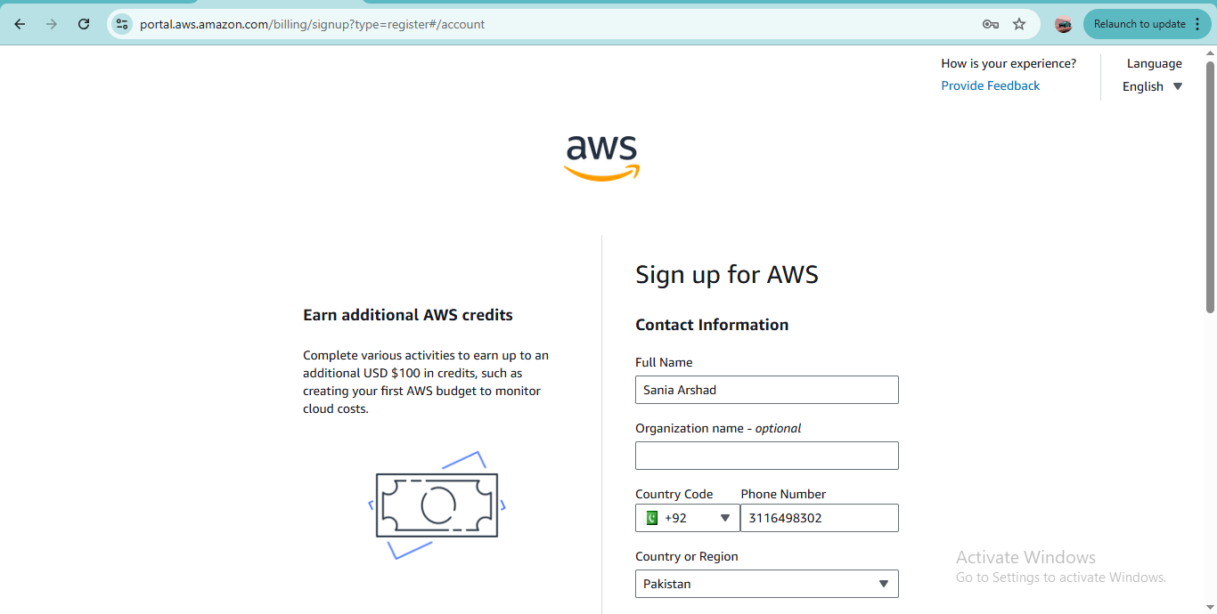

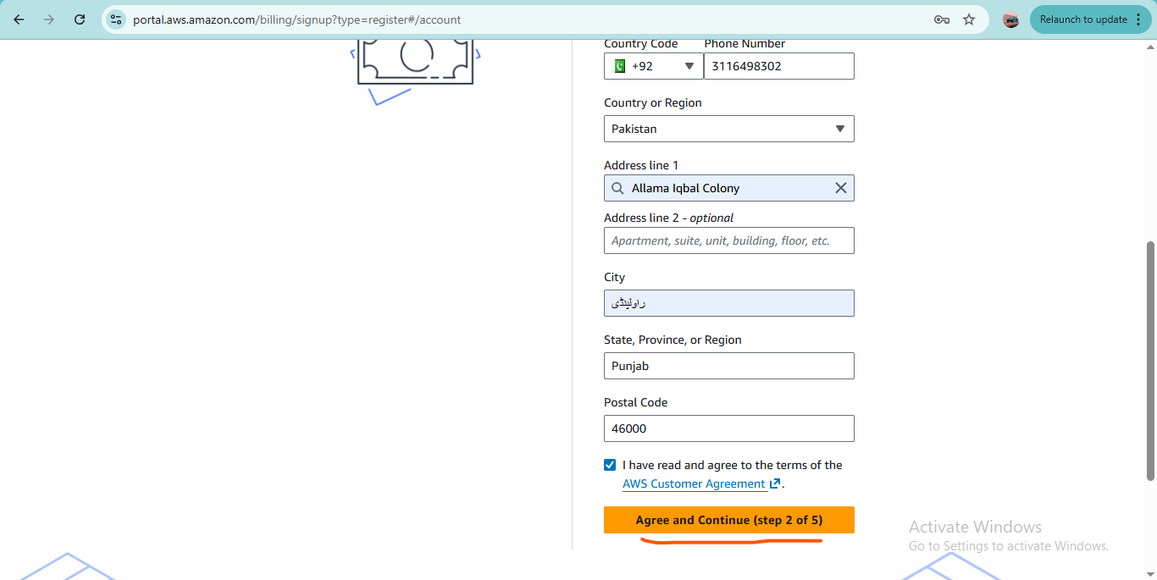

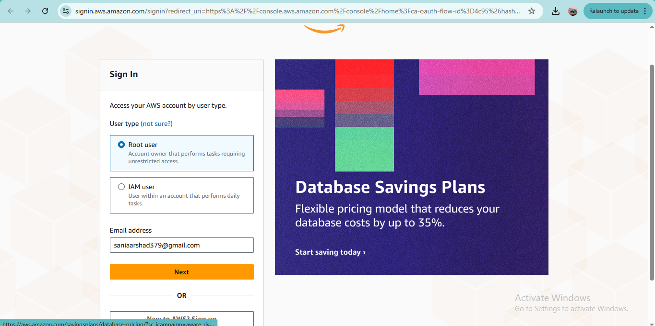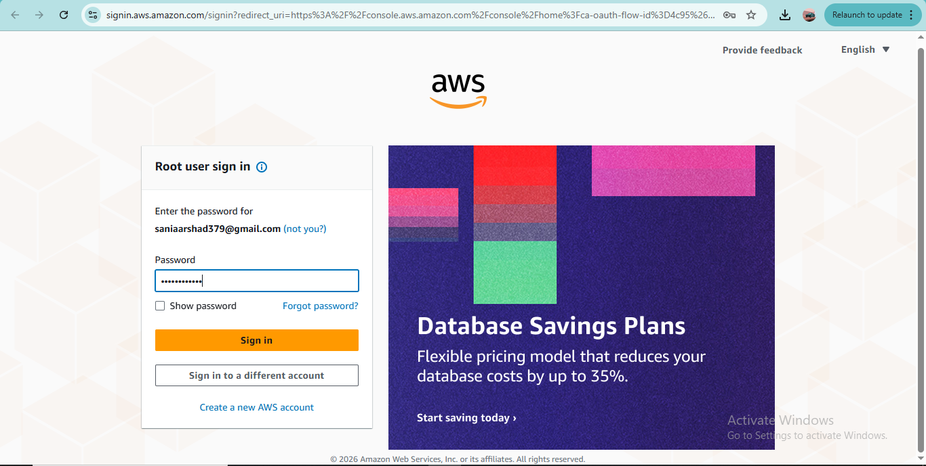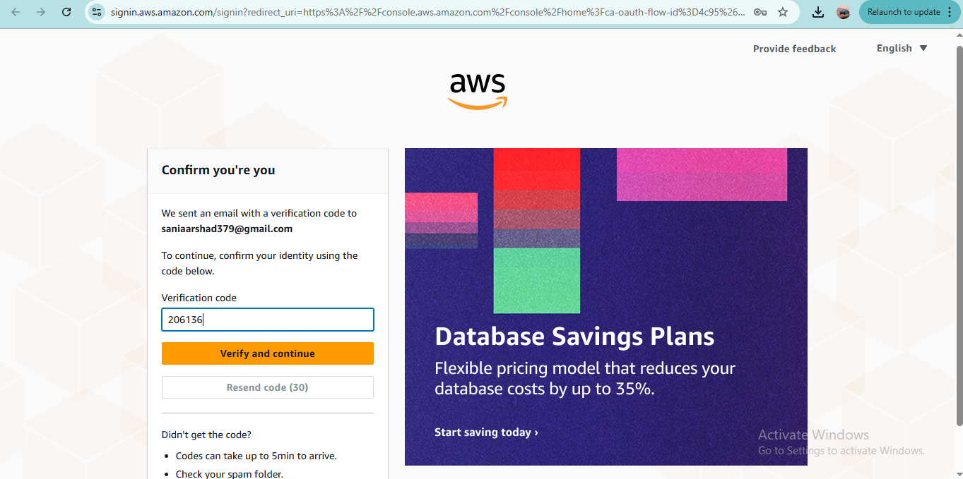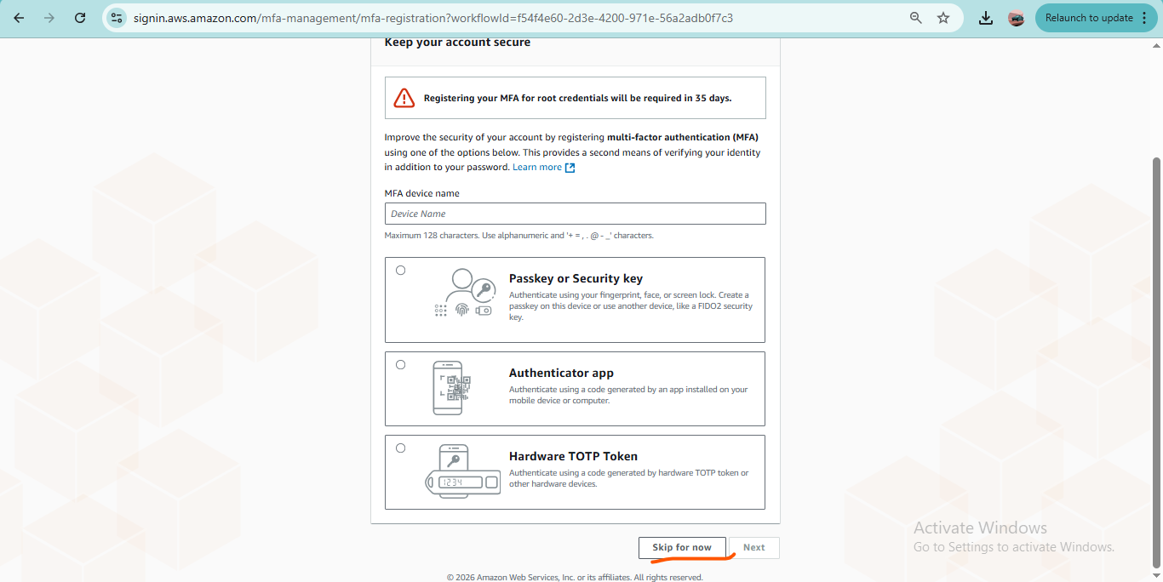 Sania@AWS379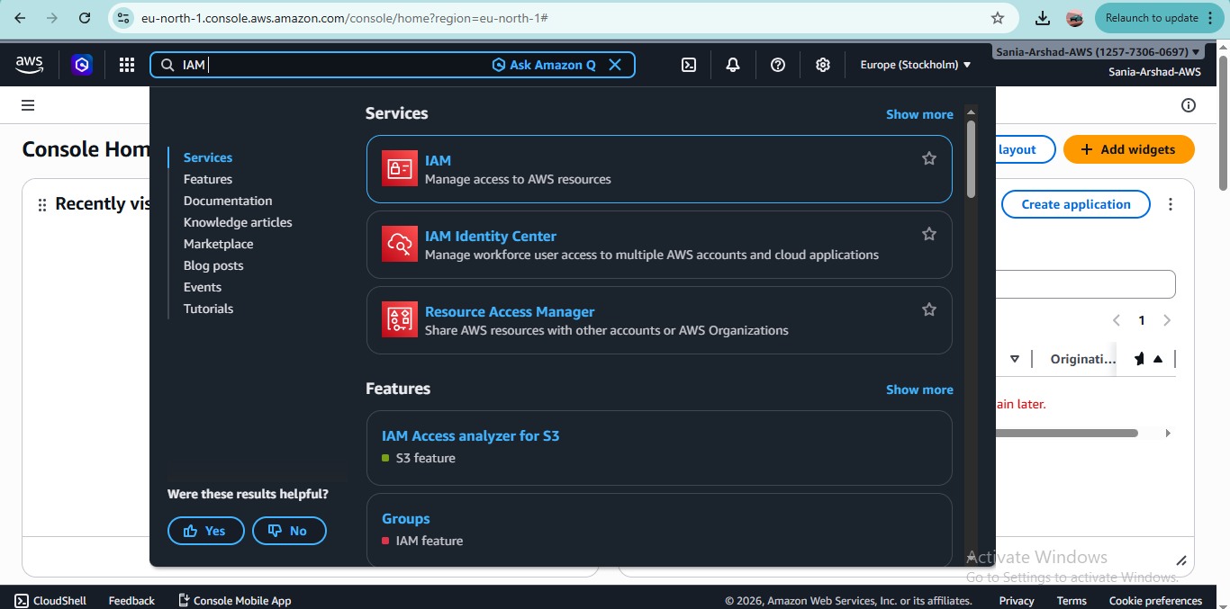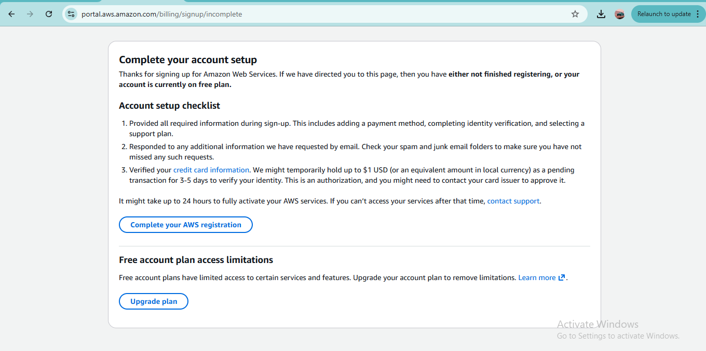
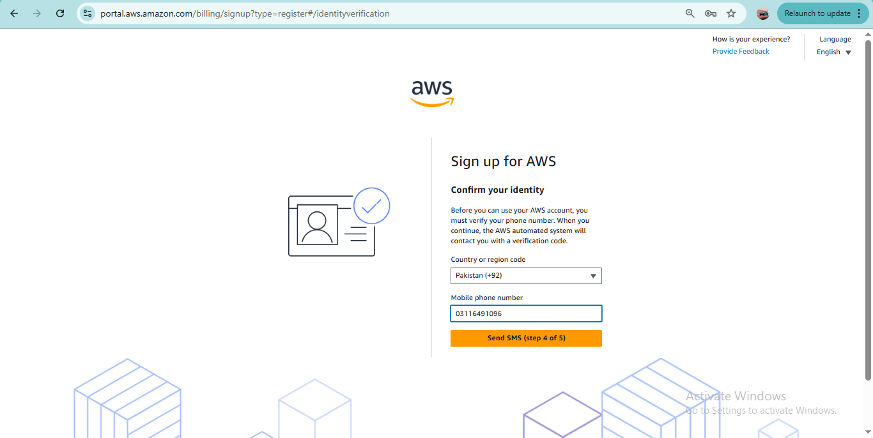 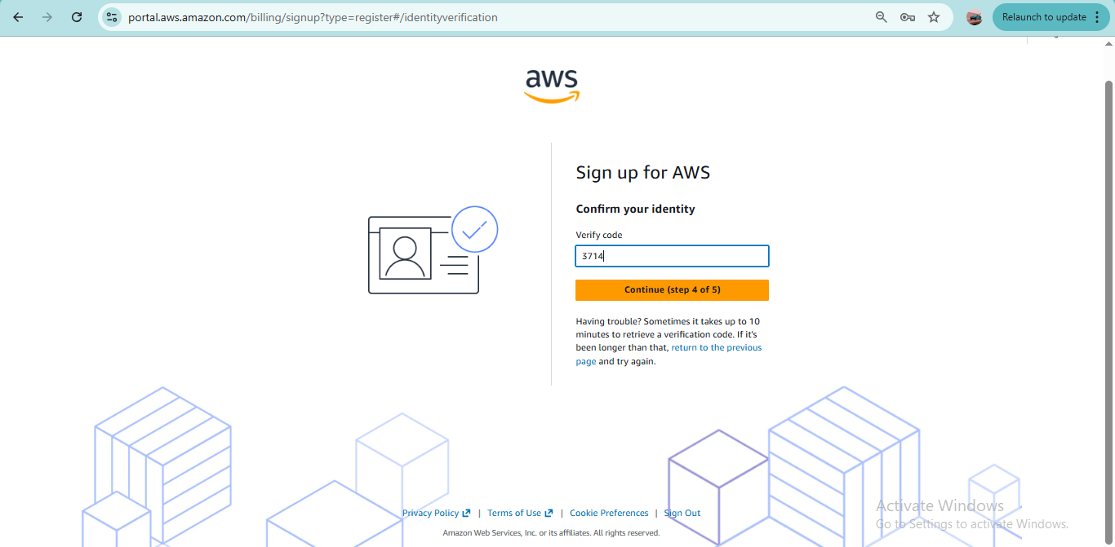’
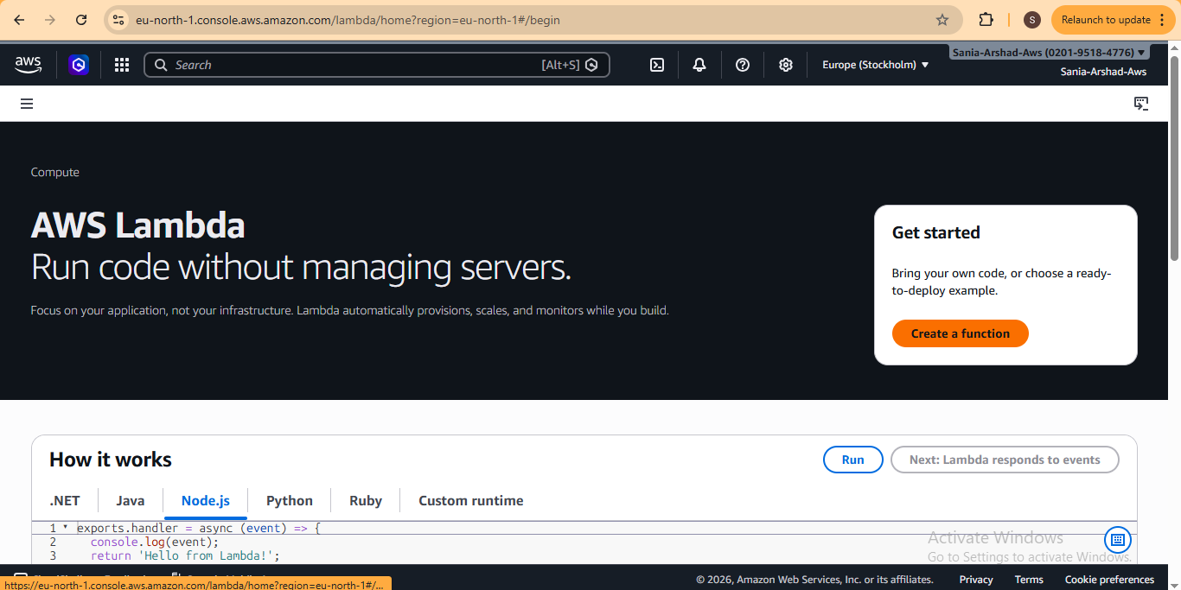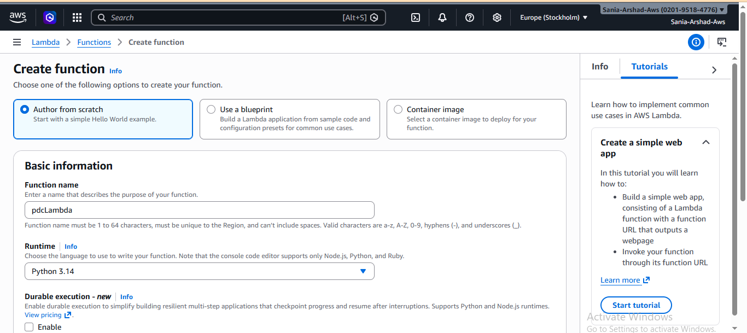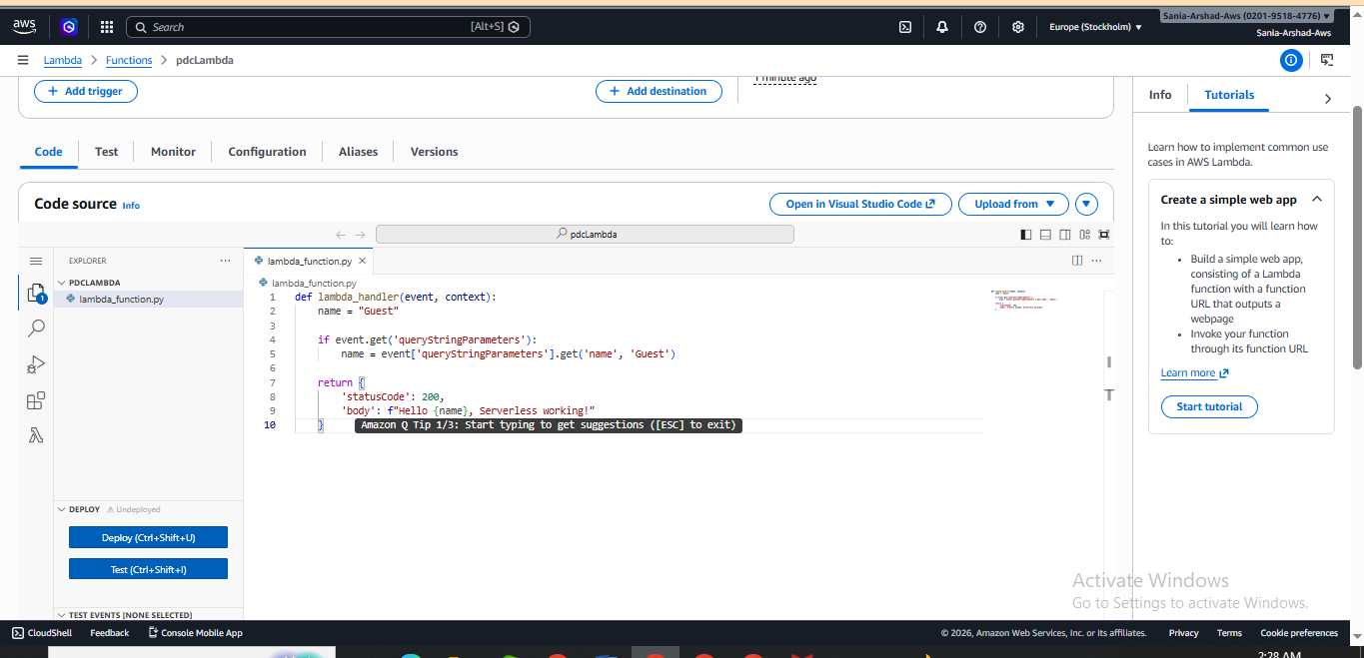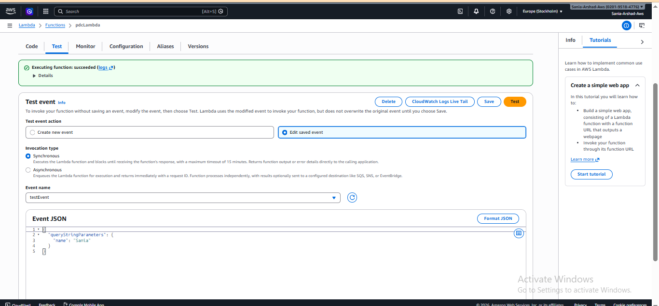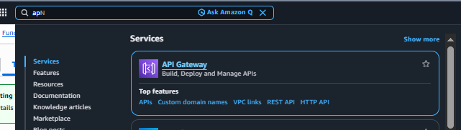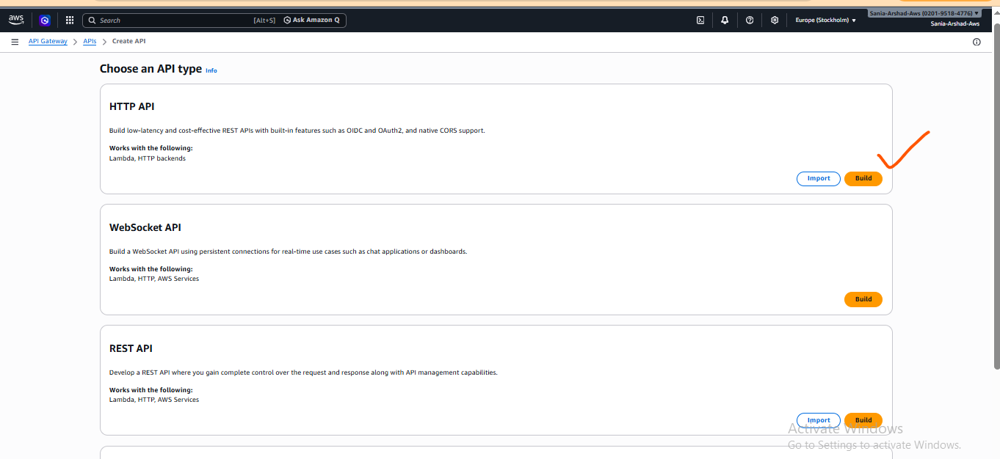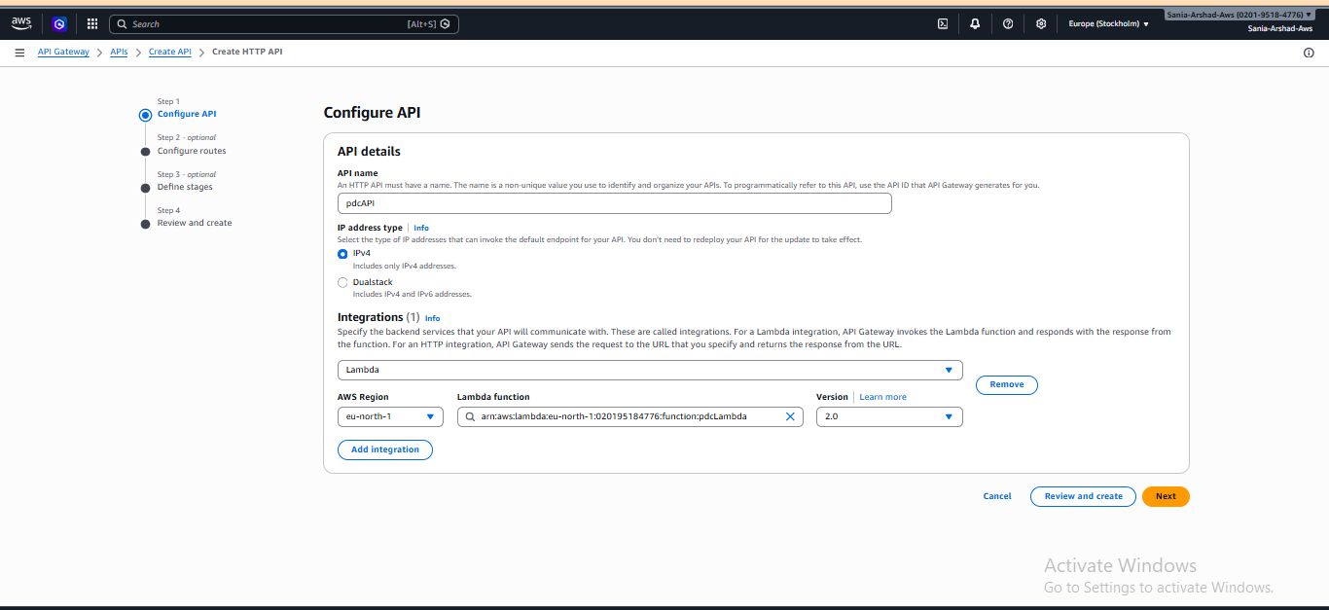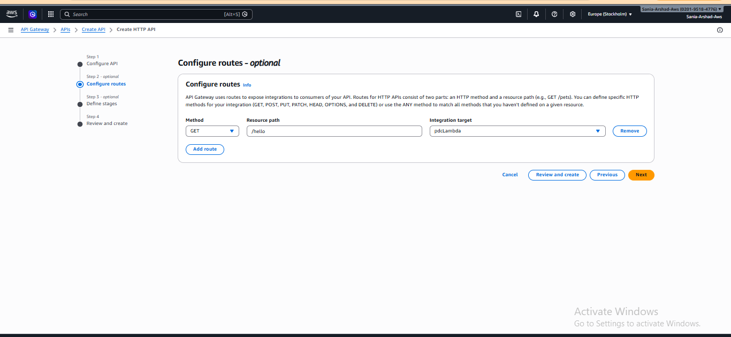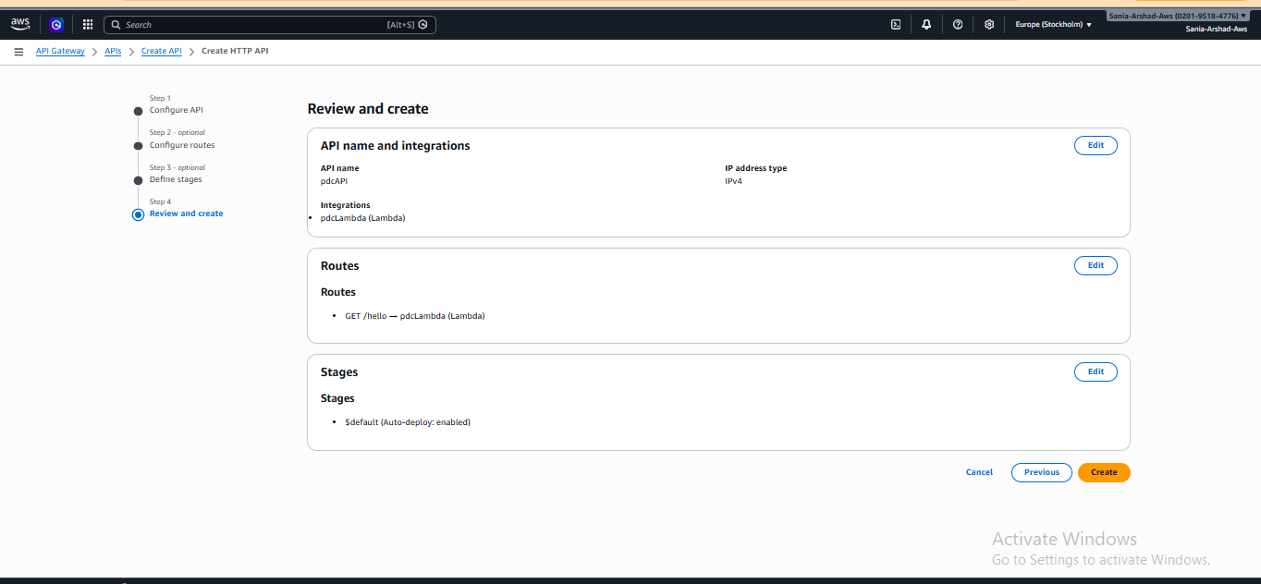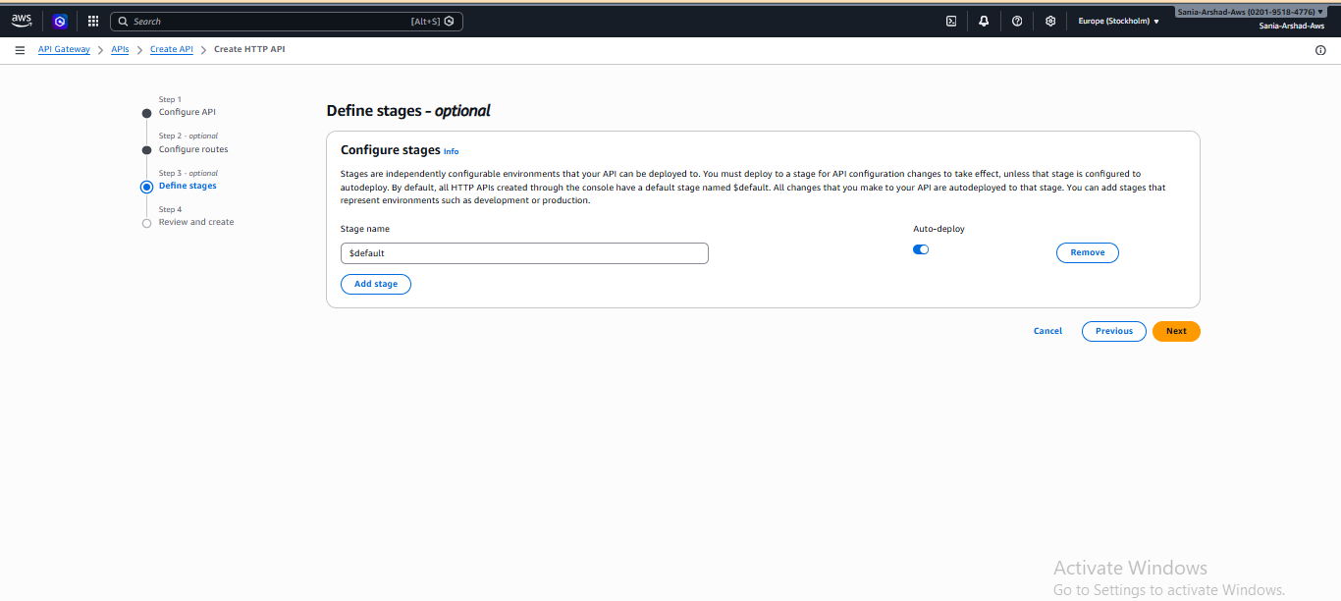

Step 4: Browser me test karo
👉 browser me open karo:
https://hwcsv22byj.execute-api.eu-north-1.amazonaws.com/hello?name=Sania%20Arshad
